**ONLINE TEST MANAGEMENT**

**Prepared For :**

Bootcamp Training Program

Capgemini Technology Services

**Prepared by :**

Samayamanthula Sri Harsha

Syed Waseem Fahad

Mandapati Mahathi

Sivaramakrishnan Thiruvengadam

 **ONLINE TEST MANAGEMENT SYSTEM**

**Problem Statement:**

To develop an Online Test Management System using java (Back End) and Angular (Front End) with various roles for admin and user.

**Description:**

The Online Test Management System is a java-based system which would help an organization who wants to conduct an exam online. This is a web-based application which can be accessed from anywhere through the web. This entire system is majorly divided in two parts i.e. user and admin, where they both have different functionalities i.e. admin can create the test, delete the test, update the test, add the questions to the test, add question to database, update the question, delete the question and assign the test to specific users. Whereas the user can give the test which is assigned by admin. This system helps user and admin to know the details of expired test and upcoming test. After completion of test by user, result will be calculated and the result analysis will be given.

**Scope:**

Using this Online Test Management System, admin can add, update, delete the test, assign test for specific users, add questions to a specific test. The admin can also delete the questions while the user can give assigned test, only one test at a given time. If the user closes his window during the test then the questions answered up to that time will be saved and result will be shown accordingly.

**Out of Scope:**

This system does not assign multiple tests to a single user at a given time and the user also cannot take multiple tests at a given time. This system does not contain theory tests and questions in it. It only contains multiple choice questions in which only one option can be selected by the user.

**FUNCTIONAL REQUIREMENTS:**

**ATHENTICATION:**

Both admin and user need to login using their credentials to access the various functionality. A signup page is needed for creating new user accounts. For the sign up of the user the user will have to give the details like username, password and email. Here the user name and the email will have to be a new one.

**ADMIN:**

The admin can add test, edit test, remove test, and he can also update the questions or even delete them .The admin will have to assign a test to a particular user for the user to access it. All these functionalities can be performed by the admin after proper authentication.

**USER:**

The user can login with his/her credentials. Once logged in he can check the tests assigned for him by registering them and can also check the results of the attempted tests. He can also see the upcoming tests in his dashboard. All these functionalities can be performed by the customer after proper authentication.

**SEQUENCE DIAGRAM (Both Admin & User)**

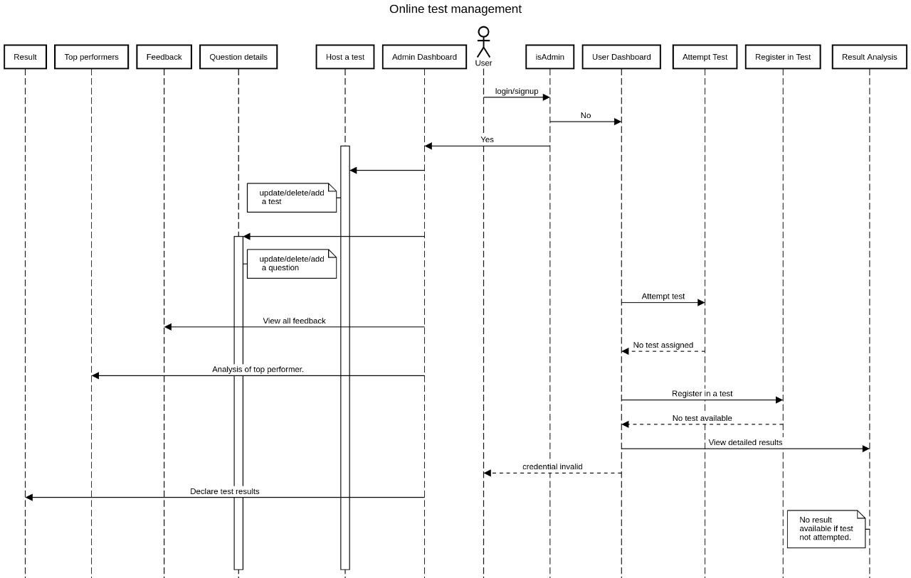

**ACTIVITY DIAGRAMS**

* Admin Login service

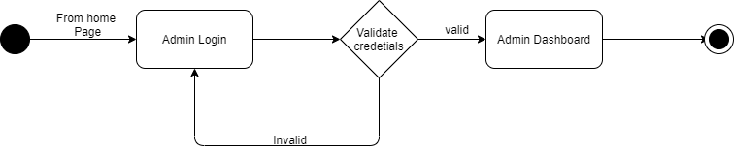

* User Login/Signup Service
* 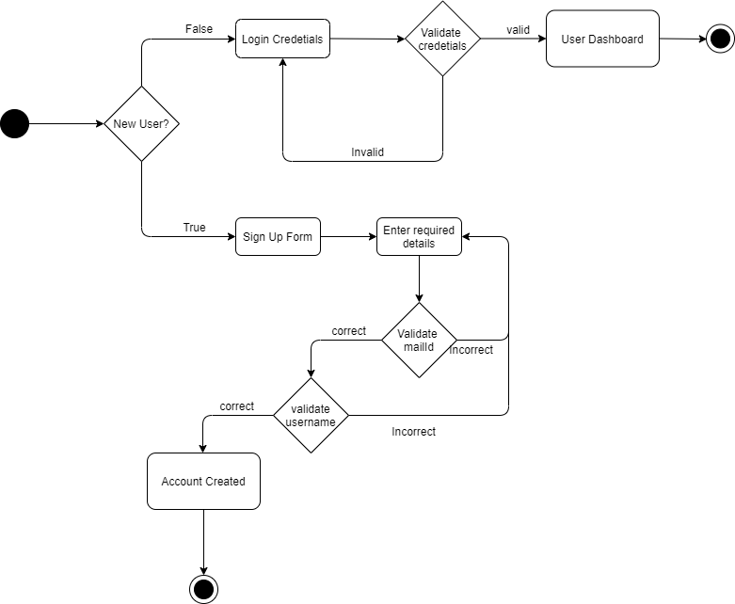
* Admin Service

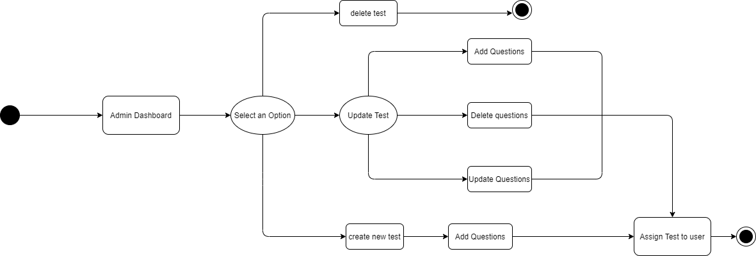

* User Service

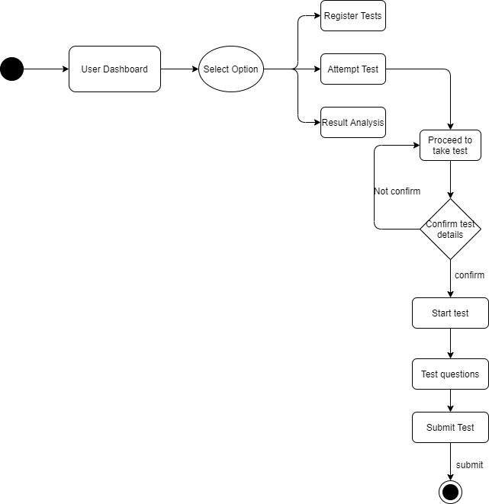

**ENTITY RELATIONS DIAGRAM :**

